Fasting & Prayer Devotional GUIDE
JANUARY 8th to 12th, 2024

THEME: CONSECRATE
Theme SCRIPTURES – JOSHUA 3:5 & EXODUS 19-20
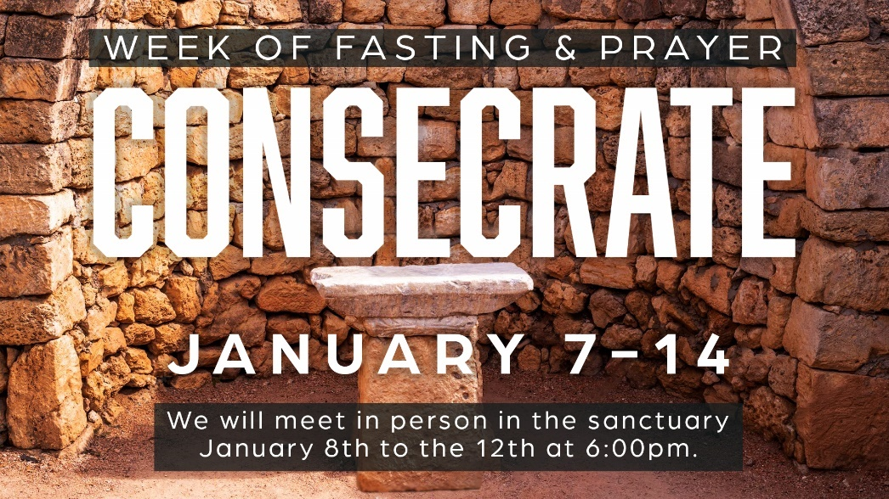
Prayer is the greatest weapon God has given the church.
fasting is the greatest discipline
to keep us focused.

Fasting & Prayer Guide

At the beginning of each year, we come together as a body of believers to seek the Lord during a week of fasting and prayer. It is a powerful time for our church family. The theme for this year’s Week of Fasting is: “CONSECRATE.”

But what does consecrate mean? By definition, it is:
1) The act of dedicating yourself to the service and worship of God.
2) To make holy or dedicate to a higher purpose.

To consecrate ourselves is to separate ourselves from common things. To focus on the LORD, and to see HIM do wonders among us.

So, what does consecration look like in your daily Christian walk? How do you become more consecrated in His service?

During our weeklong fast, each day we will focus on what it means to CONSECRATE and seek the face of God by devoting and separating ourselves from all the busyness of this life. We want God to change us. We want to be like the Church in the Book of Acts; Stronger Together in prayer, worship, giving, fellowship, compassion, consistency, witnessing and in preaching the Word.

Every day we will have a short devotional led by one of our pastors and a time of worship, prayer, and intercession.
If you need more information, contact Pastor Sam by email at svijayasenan@mcassembly.com.

DAILY DEVOTIONAL THEME (SUMMARY)
Day 1 – SELF
I CHOOSE to CONSECRATE myself by SEEKING God first through daily Prayer and Worship.
Scripture Readings: Exodus 20:22-26, Romans 12: 1-2, Matthew 6:33, John 4:23, Matthew 5:48; Matthew 6:24; 2 Tim 3:16-17

Day 2 – SELF
I CHOOSE to CONSECRATE myself by READING God’s Word and daily study and meditate on what the Bible says.
Scripture Readings: Hebrews 4:12, Psalms 119:105, Psalms 1:2, Jeremiah 15:16
Day 3 – FAMILY
I CHOOSE to CONSECRATE myself by BUILDING My Family Altar; we will intentionally make time for Prayer, reading God’s Word & Worship.
Scripture Readings: Joshua 24:15, Deuteronomy 6:4, Numbers 6:22
Day 4 – CHURCH
I CHOOSE to CONSECRATE myself through FELLOWSHIP with the body of Christ by Caring, Sharing and Praying for others.
Scripture Readings: Hebrews 10:25, Ephesians 4:12, Matthew 16:18
Day 5 – WITNESS
I CHOOSE to CONSECRATE myself by being a WITNESS in the Church, in our community, in our Nation and in Global Missions through Prayer, Giving and Going.
Scripture Readings: Matthew 28:19, Isaiah 6:8, Acts 13:1-2
DAILY DEVOTIONAL THEME (every day)
Day 1 – SELF
I CHOOSE TO CONSECRATE MYSELF BY SEEKING GOD FIRST THROUGH DAILY PRAYER AND WORSHIP
Scripture Readings: Exodus 20:22-26, Romans 12: 1-2, Matthew 6:33, John 4:23, Matthew 5:48; Matthew 6:24; 2 Timothy 3:16-17
Worship Song – Holy Forever https://youtu.be/IkHgxKemCRk?si=lwk2QBN8zX-eUJWP
I Speak the name of Jesus.
https://youtu.be/PcmqSfr1ENY?si=SHmeGUPoWeRufHm_
Personal Study

What is Prayer?

What is Worship?

What should I do to prioritize my time with God?

DAILY DEVOTIONAL THEME
Day 2 – SELF
I CHOOSE TO CONSECRATE MYSELF BY READING GOD’S WORD TO BECOME A DISCIPLE THROUGH STUDY AND MEDITATING DAILY
Scripture Readings: Hebrews 4:12, Psalms 119:105; Psalms 1:2; Jeremiah 15:16
Worship Song – The Word is… by Anna Golden
https://youtu.be/9UqDUIqZQgM?si=Gd40TtVjRDPugzbJ
Personal Study
What are my current reading habits & what do I desire for new year?

What should I do to change and cultivate reading and meditating?

What steps do I need to take to be a disciple making disciples?

DAILY DEVOTIONAL THEME
Day 3 – FAMILY
I CHOOSE TO CONSECRATE MYSELF BY BUILDING MY FAMILY ALTAR THROUGH INTENTIONALLY GIVING TIME TO PRAYER, WORSHIP & THE WORD
Scripture Readings: Joshua 24:15, Deuteronomy 6:4, Numbers 6:22
Worship Song – Blessing – “Elevation”
https://youtu.be/jDMijhOUOqk?si=71zXs3Ha0YL81CkJ
Personal Study:
What is a practical way I can bring my household together for a Family Altar time?

What time works best for our family time?

How can I use social media for family altar time?

DAILY DEVOTIONAL THEME
Day 4 – CHURCH
I CHOOSE TO CONSECRATE MYSELF THROUGH FELLOWSHIP WITH THE BODY OF CHRIST BY CARING, SHARING AND PRAYING FOR OTHERS.
Scripture Readings: Hebrews 10:25, Ephesians 4:12, Matthew 16:18
Worship Song: Build Your Church – Elevation & Maverick worship.
https://youtu.be/wegtdmbeuh0?si=XX6CXOSaN_ZFOz2p
Personal Study

What steps should I take to be involved in the Church?

How can I encourage other believers who are in need?

How can I be part of prayer and discipleship in the future?

DAILY DEVOTIONAL THEME
Day 5 – WITNESS
I CHOOSE TO CONSECRATE MYSELF BY BEING A WITNESS IN THE CHURCH, IN OUR COMMUNITY, IN OUR NATION AND IN GLOBAL MISSIONS THROUGH PRAYER, GIVING AND GOING.
Scripture Readings: Matthew 28:19, Isaiah 6:8, Acts 13:1-2
Worship Song: Praise – Elevation Worship
https://youtu.be/raFnjGVkHe8?si=kB-zddpIRQ52o6C0
Personal Study
Am I called to be a witness to my community? If so, how?

I have never been part of a mission’s trip. What steps should I take?

How can I be involved in Global Missions?

