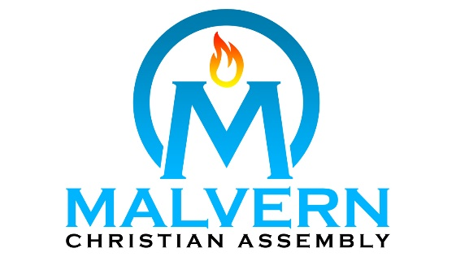

Summer Day Camp Leader Application |  |  |  |  |  |  |  | Please print or type. The application must be fully completed to be considered. Please complete each section, even if you attach a resume.
Personal Information
Name
Address |  |  | City |  |  | Province |  | Postal Code
Phone Number |  | Mobile Number | Email Address
Birth Date |  |  | Are You Eligible to Work in Canada?
 |  |  | Yes |  | No
Education
School Name |  |  |  | Years Attended |  |  | Degree Received (if applicable)
[
References [at least 1 Adult (non-relative) and 1 Pastoral Reference]
Name |  |  | Title |  |  | Company |  | Phone
Social Media [please provide social media names/handles]
Twitter |  |  | Instagram
Facebook |  |  | Other

Spiritual History:

Do you attend Malvern Christian Assembly or another church (please list)? _________________________
How long have you attended? ________________________
When did you accept Christ as your Saviour? _________________________________________
Have you been baptized in water? Yes _____ No _____
Briefly describe your testimony/conversion experience.
____________________________________________________________________________________________________________________________________________________________________________________________________________________________________________________________________________________________________________________________________________________________________________________________________________________________________________________________________________________________________________________________________

Lifestyle:
In order to provide a safe and secure environment for our children, we believe it is necessary to include the following questions as part of our application process.

Have you ever been convicted of a felony? If yes, please explain:
____________________________________________________________________________________________________________________________________________________________________________
Have you ever been convicted of a crime involving children? Yes _____ No _____
Have you ever been disciplined for, charged with, or convicted of an act of sexual misconduct or child sexual abuse? If yes, please explain
____________________________________________________________________________________________________________________________________________________________________________
What are you doing in order to grow spiritually?
_____________________________________________________________________________________________________________________________________________________________________________________________________________________________________________
Are you currently or have you ever been involved in a church ministry to children? (Please list them)
____________________________________________________________________________________________________________________________________________________________________________
Which MCA ministries are you currently regularly involved in pre-COVID? (“regularly” means that you are involved at least once a week)
____________________________________________________________________________________________________________________________________________________________________________
Why would you like to work at the MCA Summer Day Camp?
__________________________________________________________________________________________________________________________________________________________________________________________________________________________________________________________________
Please list any skills or related talents/hobbies that would be an asset to our program.
__________________________________________________________________________________________________________________________________________________________________________________________________________________________________________
Are you trained in First Aid , CPR , and/or lifeguarding ? Yes ___ No ___

Please read the following:
MCA Day Camp Statement of Faith and Conduct
I believe that Jesus Christ died for my sins and has risen again giving me eternal life and a relationship with Him. I further believe that the Bible is God’s inspired Word and our final authority, teaching us about Him and His plans for our life. As a counsellor, I recognize that I will be looked up to by the campers and therefore have a responsibility to conduct myself as a reflection of Jesus Christ, both at camp and outside of the Church. With the help of God, I will follow the MCA regulations and live an exemplary life to encourage and benefit both the campers and staff at MCA’s Summer Day Camp. I will participate in all training opportunities and I will conduct myself as the Christian example I am called by God to be. I understand that the Camp Directors & Coordinators will be allowed to review this application for staff planning purposes.

Do you agree to follow the Statement of Faith and Conduct? Yes ___ No ___

How will you apply the principles in the Statement to your life?
________________________________________________________________________________________________________________________________________________________________________________________________________________________________________________________________________________________________________________________________________________________

Prerequisites for Counsellors
- Minimum age of 17 yrs. old.
- Completed Police reference check
- Excellent communication skills
- Strong work ethic
- Ability to work as part of a team
- Experience working with children

Preferred
- Actively involved in at least 1 ministry at Malvern Christian Assembly
- Regularly attend Sunday services at Malvern Christian Assembly

As a Counselor you must:
- Be available to work 35hrs./week for 8 weeks (plus additional hours for Training),
- Assist in all areas of the daily camp routine
- Create a positive spiritual & physical growing experience for campers

