Marching to Moab
Numbers 10:11 – 12:16

Intro
- Numbers is not the most ________-__________ book with just a couple of widely referenced passages:
- Num. ___:___ – “see what God has done.”
- Num. ___:___ – “be sure your sin will find you out.”
- In the Hebrew bible, the title of Numbers is, “the Lord said.”
- New title in Greek: arithmoi (where we get the word ______________________).
- In Latin, translated as numeri.
- Numbers begins and ends with a ____________.
- The book of Numbers tells us that there is nothing wrong with ________________!
- We’re told that _______ were added to the Church on the day of Pentecost.
- Jesus encouraged His followers to __________ the cost of following Him.
- Facts about the Figures.
- They are __________.
- They are ______________.
- They are __________________.
- Most of the lessons we learn from Numbers are ________________.
- Too many Christians brought out of sin . . . end up in a __________________ wilderness.
- According to Paul, if you do not study history, you are condemned to ____________ it.
- At first glance, Numbers is a mixture of narrative and __________ – like Exodus.
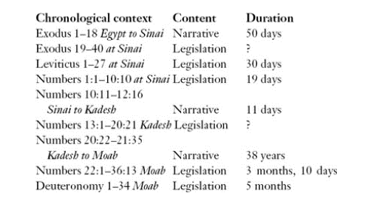
- The stories of their travels show how they __________ those laws.
- While they were ______________________, God told them what they should do.
- While they were ____________, we hear the story of what they did do.
- They would learn lessons both ways: through the teaching from Moses and the experiencing of journeying.
- Preparation for the journey:
- Celebrate the Passover (9:1-14)
- Number the soldiers (chapter 1)
- Organize the tribes (chapter 2)
- Assign the priestly duties (chapters 3-4)

Order in the Camp (Num. 9:1-14)

- They began their ____________ year by celebrating the Passover. (9:2)
- There is a new situation which demands new ____________. (9:6-7)
- God was not establishing a __________________ Passover. (9:10-11)
- This was the ________ Passover they celebrated until the Promised Land.

Marching at God’s Command (Num. 10:11-36)

- The people had been living in the ________ __________ for nearly a year.
- Their inheritance wasn’t Mt. Sinai, it was the ________________ ________.
- In each new experience of life, we either:
- __________ God, or
- ______________ God.
- The future lay with those who trusted Jehovah and ____________ His laws. (10:29)
- Divine providence does not minimize human ______________ or
___________________________
- Proverbs 3
- Romans 12
- Moses ______________ others to enjoy the blessings God had prepared for them. (10:29)
- God, not __________ was in charge of the nation. Israel was an army that depended on the Lord for victory. (10:35-36)
- It takes __________ to be able to accept God’s providential leading. (Num. 11)
- When the leaders sin, the consequences can be ____________________.
- God made it clear: Moses was ________ than a prophet. (12:7)
- A rebellious ____________ always holds back back the progress of God’s people.

